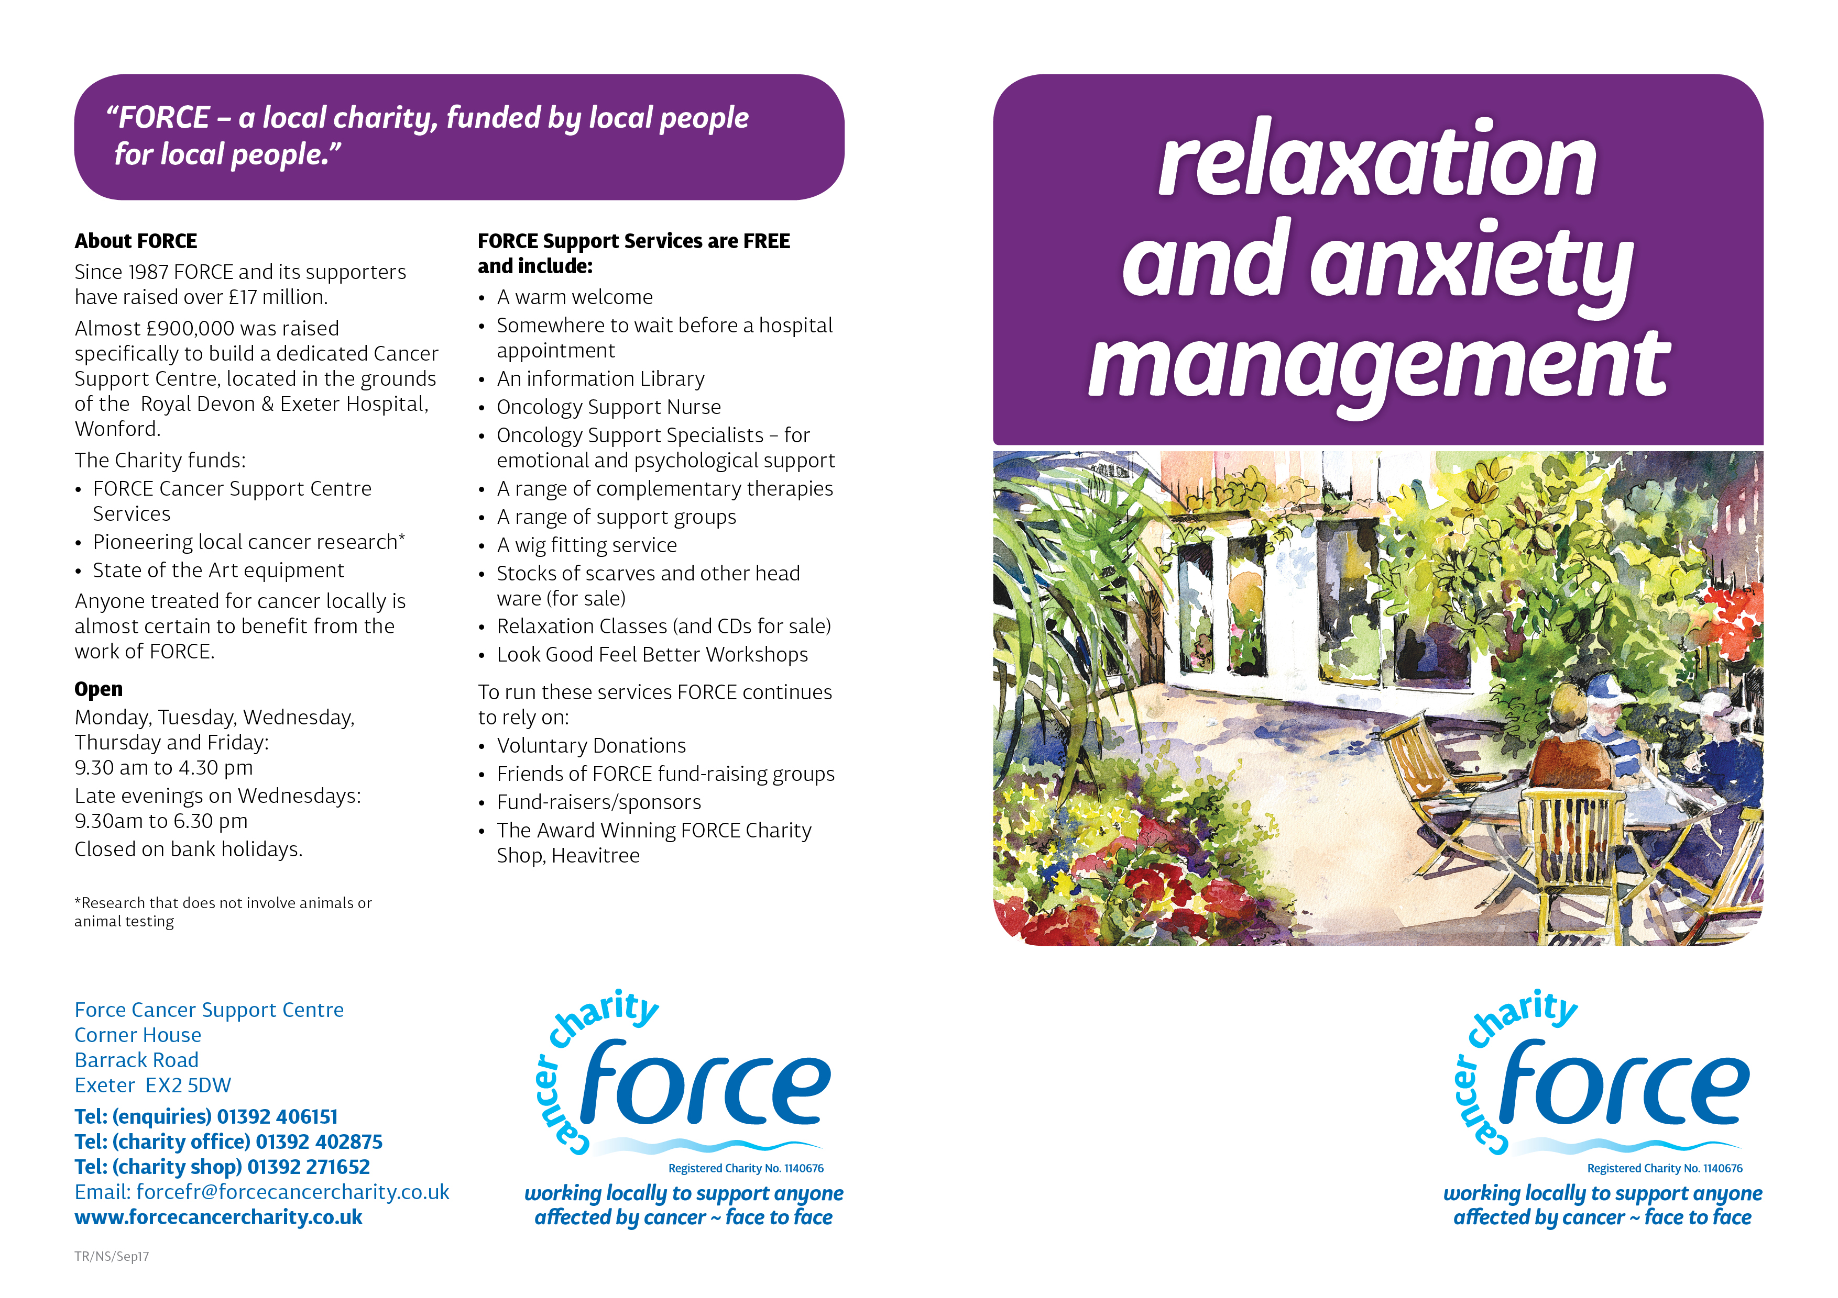

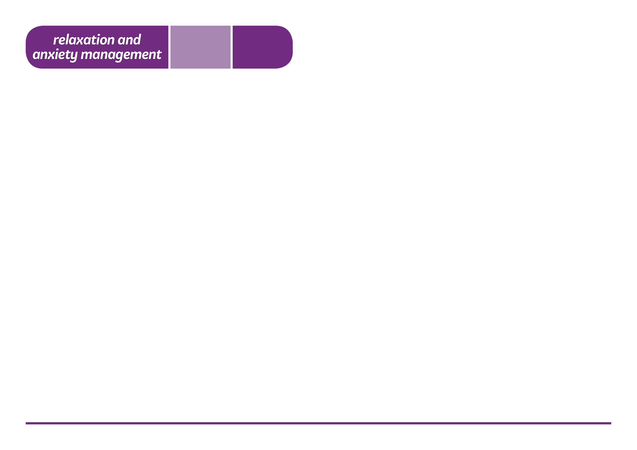

Hearing that you or someone close to you has cancer can be a distressing experience. A diagnosis is often accompanied by a range of different emotions and responses, some of which can be helped by relaxation and anxiety management techniques.

**Relaxation can.....**

• Relieve tiredness and stress

• Help manage anxiety

• Enhance coping ability

• Help restore and replenish the mind and the body.

• Contribute to a sense of well-being and peace

**Who is it for?**

Anyone affected by cancer who would like to:

• Learn relaxation techniques

• Meet other patients and carers

• Have time out for yourself

**Do I need to bring anything?**

No, but it is a good idea to wear loose, comfortable clothes. Relaxation chairs, blankets and pillows are provided.

**Where?**

Meet in the Reception Area of the FORCE Cancer Support Centre.

There are two options to choose from:

**Relaxation Drop-in Classes**

These sessions offer an opportunity to discover and practise guided relaxation. Please contact us for details on:

**🕿** 01392 406151

**A Six-Week Relaxation & Anxiety Management Course**

Relaxation is a skill which anyone can learn. This course provides a supportive environment to:

* Learn relaxation
* A space to practice simple skills
* Explore anxiety management skills and resources
* Encourage bringing your learning to everyday life

This course runs three times a year and needs to be pre-booked. For information, dates and booking please phone:

Emma **🕿** 01392 403051

**Relaxation CDs** are available from our Support Centre. Each CD contains: lead-in music, guided relaxation, music to help you stay relaxed, a brief visualisation and guidance for ending your relaxation.

09/19